**Table of contents**

**Glossary of acronyms** (1 page)

**Acknowledgments** (1 page)

**Abstract** (1 page)

**List of figures**

**List of tables**

**General introduction** (1 page)

1. **Project Context** (8-9 pages)
   1. Introduction
   2. Host company presentation
      1. Sofrecom Tunisia presentation
      2. Sofrecom activity
   3. Project presentation
      1. Problem Statement
      2. Project objectives
   4. Critical analysis of the State of the Art
      1. State of the art
         1. Samknows One
         2. SMAQ
      2. Critical of the state of the art
      3. Proposed solution
   5. Modeling language
   6. Software development methodology
   7. Conclusion
2. **Requirements analysis and specification** (12-14 pages)
   1. Introduction
   2. Identification of the Actors
   3. Functional requirements
   4. Requirements analysis
   5. Nonfunctional requirements
   6. Conclusion
3. **Design of the physical and logical architectures** (18-20 pages)
   1. Introduction
   2. Physical architecture
   3. Logical architecture
      1. Conceptual model
      2. Modular decomposition
      3. Broadband supervision and monitoring theory
   4. Conclusion
4. **Project Achievements** (18-20 page)
   1. Introduction
   2. Developing environment
      1. Hardware environment
      2. Software environment
      3. Frameworks and technologies
   3. Achieved work
      1. Authentication
      2. Devices management
      3. Metrics and tests management
      4. Statistics and dashboard management
      5. Alerts management
   4. Conclusion

**General conclusion and future work** (1 page)

**Bibliography**

**Netography**

**Glossary of acronyms**

**Acknowledgements**

**Abstract**

This report describes the design and the development of our graduation project internship, which is carried out at Sofrecom Tunisia, the project consists in creating a remote and communicating devices platform to achieve broadband supervision and monitoring and assess the quality of service “QoS” of fixed network access.

With our solution, the user could manage connected probes and create broadband tests configuration before running them in the probes, also he could manage statistics configuration with attractive charts for testing results. Users could create customized alerts configuration to simplify broadband supervision. The project also helps network supervisors to get accurate statistics according to a time period and zone area.

**Keywords:**

Probe – Spring boot – Angular – Raspberry Pi – Java – Kafka – Broadband

**General introduction**

With the global spread of the internet nowadays, many mobile and internet services operators appear. In the coming days, connected devices will spread massively worldwide, especially with the appearance of new technologies such as the internet of things, big data, personal area networks (PAN), artificial intelligence (AI). So mobile and internet services operators desire to achieve a better quality of service for their customers. To do so, operators design and develop solutions for broadband monitoring and supervision mainly to massively assess and monitor the quality of service of networks access perceived by customers. Sofrecom Tunisia, subsidiary of Orange Group, attempts to serve this purpose by designing and developing a platform for broadband supervision and monitoring and specific to massively assess the quality of service (QoS) of fixed network access. In this context comes our mission during the graduation project internship.

This report contains four chapters as follows:

The first chapter titled “Project context” will be devoted to the company presentation and setting the project in its general context.

The second chapter “Requirements analysis and specification” will be about the global system analysis to design and develop.

The third chapter “Design of the physical and logical architectures” will be dedicated to present physical and the logical architectures of our solution, also, we will explain the theory behind the broadband monitoring and supervision.

At last but not least, the final chapter “Project achievements” will be about the application achievements. First, we will present the developing environments and technologies and tools, secondly, we will illustrate our application with several interfaces.

Finally, we will close the report with a general conclusion, future work and perspectives will be mentioned at last to illustrate some ideas to improve our solution.

**Chapter 1: Project context**

* 1. **Introduction:**

In the first place, this chapter will be about the host company Sofrecom Tunisia presentation, a consulting and engineering firm specializing in telecommunications. Then, we will talk about the work and the project environments, by putting the light on the project goals and the analysis of the state of the art. Finally, we will present our software development methodology and the modeling language that we are going to use.

* 1. **Host company presentation:**

Sofrecom, a subsidiary of Orange Group, has built up 50 years’ worth of unique know-how in the telecoms operator line of business, making it a world leader in telecom consultancy and engineering. Sofrecom Tunisia is the youngest subsidiary of Sofrecom. Launched in November 2011, Sofrecom Tunisia expands Sofrecom’s presence in North Africa and the Middle East region to meet the growing demand for dedicated solutions and to offer its customers adapted and competitive offers.

* 1. **Project presentation:**
     1. **Problem statement:**

Operators of mobile and internet services have probes, Key Performance Indicators (KPIs), installed in several network elements, but they desire to appreciate the quality perceived by their customers (Quality of Experience, QoE) in order to improve their network performance and reliability.

In order to get accurate informations about the quality of experience we should get the measurements according to zone area and specific periods of time. Also, it is difficult to manage the configuration and QoS/QoE tests running in the widespread probes, which indicates a lack of flexibility. The internet usage is improving fast; therefore we should improve the quality of service measuring as well.

* + 1. **Project objectives:**

This work will be considered as a graduation project to obtain applied computer science diploma from the national engineering school of Sousse (ENISO).

The main project goal is to design and develop a platform for remote and communicating devices, to serve broadband monitoring and supervision. The application should satisfy these needs:

* The creation and interpretation of messages exchanged with terminals and embedded equipment.
* Information exchanges with client applications (northbound interface).
* Management of messages from terminals (southbound interface).
* Sending requests and messages to the terminals.
* On-the-fly supervision of exchanges.
* Management of supervised elements.
* Resolution of message referral rules.
  1. **Critical analysis of the state of the art:**

This step is essential to propose our solution in the relation to those offered by other companies. To do so, we have studied the characteristics and the features of some available apps while we focus on their weak points.

* + 1. **State of the art:**
       1. **Samknows One:**

The SamKnows One is a cloud-based analytics platform that includes a full range of measurement agents for fixed and cellular internet connection with a global test infrastructure. The SamKnows solution stores and visualizes performance data in real-time. This solution is implemented by a UK company “Sam” founded in 2008 by Sam Crawford. SamKnows One has developed a suite of tests as follows:

* Speed tests: includes download and upload over TCP and UDP speed tests.
* Latency, loss and jitter: latency, jitter and packet loss over UDP, latency over HTML5.
* DNS resolution: DNS resolution time and failure rate (UDP).
* Web browsing: web browsing test over TCP.
* CDN performance: content delivery network (CDN) measurements over TCP.
* Video streaming: video streaming measurements that stream real content from major video streaming providers.
* Gaming: measures performance for a number of major games.
* Online storage: tests upload and download from popular online storage services.
* Voice over IP: measures the quality of a voice call between client and test server.
* Traceroute: tests the path that traffic takes around the internet, it is useful in diagnosing routing issues.
* Data usage: measures of data used on the broadband connection.

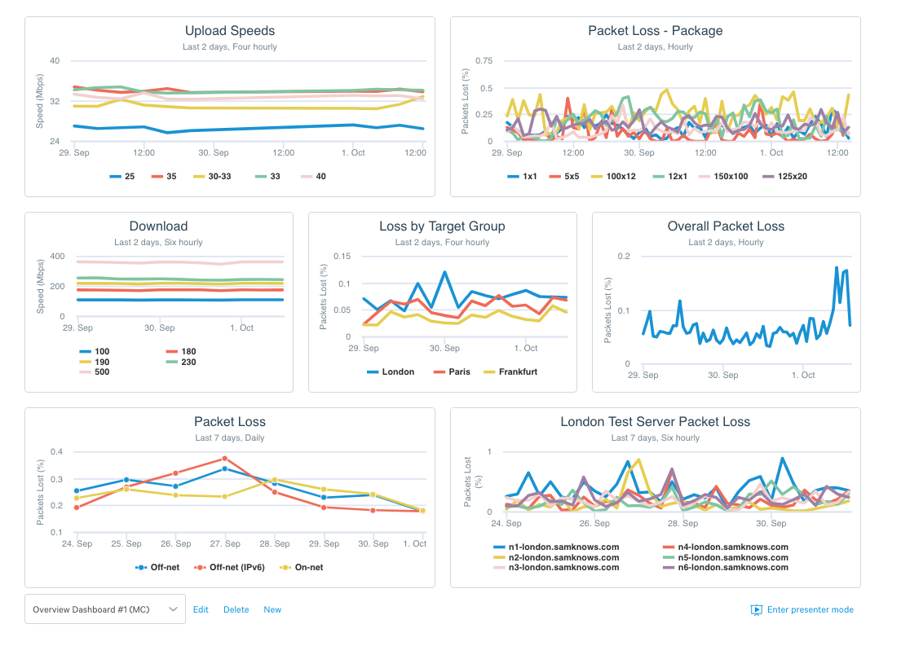

Figure 1.1: Screenshot of SamKnows One dashboard

* + - 1. **SMAQ:**

SMAQ is a solution implemented by Sofrecom to generate reports and analysis based upon different broadband tests, this solution is used by the Orient Middle East and Africa Orange affiliates.

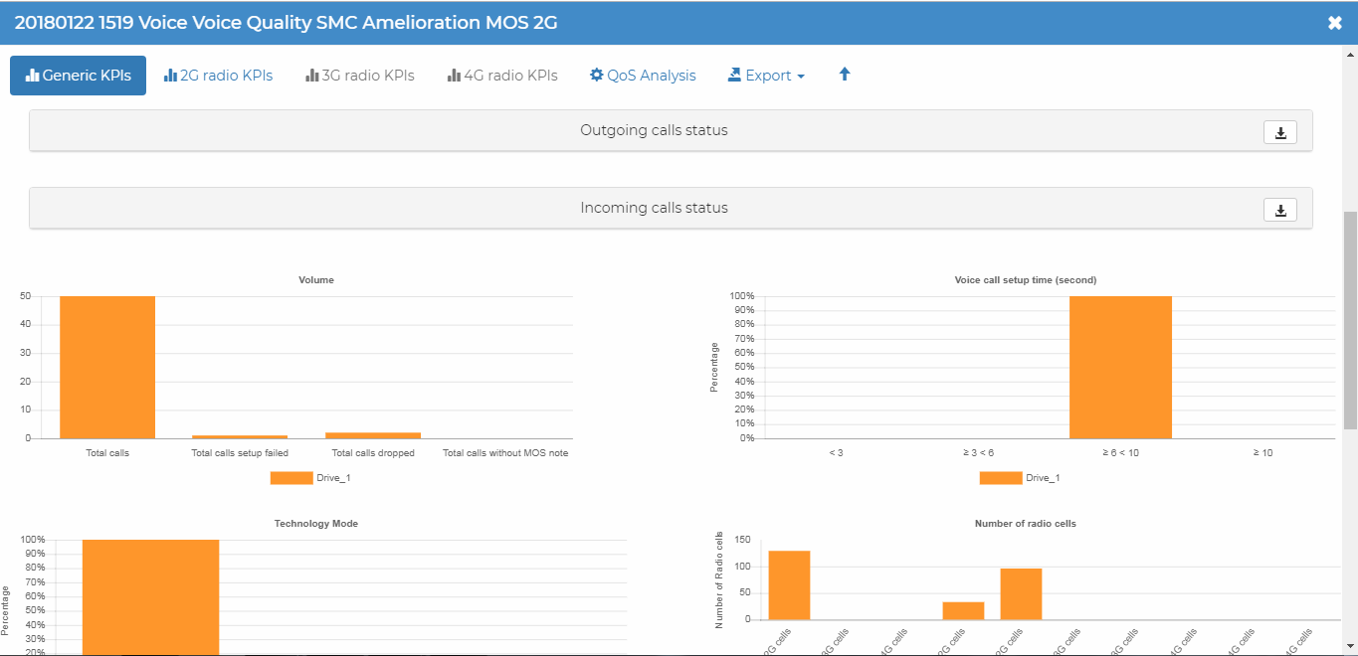

Figure 1.2: Sample of SMAQ online dashboard

* + 1. **Critical of the state of the art:**

The following table shows in detail the difference between the two mentioned solutions:

|  |  |  |
| --- | --- | --- |
| Solution | SamKnows One | SMAQ |
| Paying solution | YES | NO |
| Analytics | YES | YES |
| Custom dashboard | YES | NO |
| Mapping data | YES | YES |
| Generate reports | YES | YES |
| Network monitoring (alerting) | YES | NO |
| User management | YES | NO |
| Devices management | NO | NO |
| Tests management | NO | NO |

Table 1.1: Comparison of state of the art

Sofrecom Tunisia is looking for an open source solution for the issue in question so SamKnows One solution is not convenient for them, in the other hand SMAQ provides just the basic functionalities. The weak point in the mentioned solutions, they don’t give users the access to devices configuration. Network supervisors can’t customize tests to satisfy their specific needs.

* + 1. **Proposed solution:**

The solution proposed by Sofrecom Tunisia is to design and develop a platform for broadband monitoring and supervision, “SMAQ Probes”, the solution should respond the following needs:

* Online device management and task scheduling.
* Online test management.
* Online statistics and customized charts configuration.
* Online alerts configuration and customization.
* Online user management
  1. **Modeling language:**

During the work on our solution we used UML “Unified Modeling Language” for describing and modeling the specifications of our project. UML is a flexible and versatile modeling language, also it is the most popular and widely used by the community. We are going to present some diagrams from UML that we find it useful during our work:

* Use case diagram: it helps to structure the needs of users and the corresponding objectives of our system by identifying its users and their interactions.
* Sequence diagram: it is a time focus representation of objects and their interactions.
* Package diagram: it gives an overview of the application packages. It is a high abstraction that presents the application modularity.
* Class diagram: it gives a presentation of classes and interfaces of our system and relations between them.
* Activity diagram: it gives an overview of the dynamic aspects of the system.
  1. **Software development methodology:**

Before starting the project design and development, we should choose appropriate software development methodology to work with. The software development methodology helps to describe the different phases and the sequences of application development process.

During our project, we used agile kanban because it is a most convenient method to us. I am the only intern working on the project. Changes in the project can happen any time. We are continuously improving the flow of work. We are trying to limit work in progress and to maximize efficiency. Also, we focus on reducing the time it takes to take a project from start to finish.

* 1. **Conclusion:**

In this chapter, we presented the general context of the project by presenting the host company Sofrecom Tunisia, the problem statement and the state of the art.

In the next chapter, we will model the requirements of our solution through use case diagrams.

**Chapter 2: Requirements analysis and specification**

**2.1 Introduction:**